**1) Develop a PRPC scenario using the following with Dynamic Select**

Step1: Create Address, Country, State, City data classes

Step2: Create Pages for above classes in work class

Step3: Create Dropdowns for Country, State and City

Step4: Develop Dynamic Select for Country, City and City, State

**Conditions:** Whenever User Selects Country from Country Dropdown, respective Cities should be populated into city drop in the same way if a user selects a city from city dropdown, respective states should be populated into state dropdown.

**Output For Country And State:**

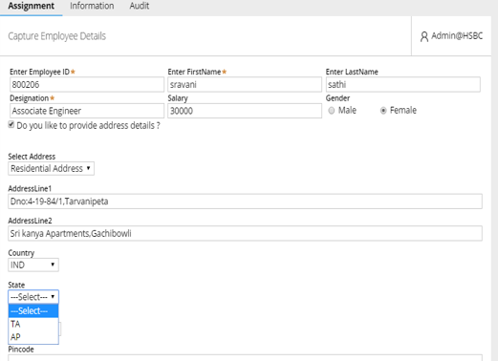

**Output For State And City:**

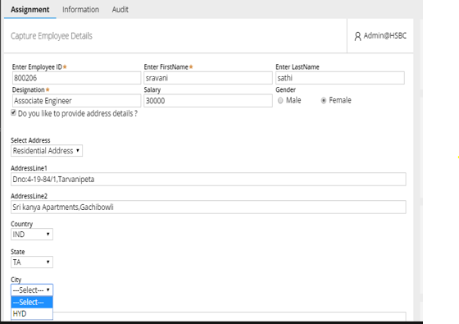

**2) Develop A PRPC Scenario Using The Following**

Step1: Create a checkbox as Do u Want Address Field?

Step2: Create a Dropdown with values Residential Address and Permanente Address

Step3: Create a Dynamic Layout with All Address Fields

Step4: Create another checkbox as Is Permanente Address Same as Residential Address?

Step5: Create another Dynamic Layout with Same Address Fields

**Conditions**: Whenever we select first Checkbox it should display dropdown after selecting any one of the options it should display address fields if we check Residential Address Is same as Permanente address checkbox all the residential address field values should be copied in Permanente address fields.

**Output:**

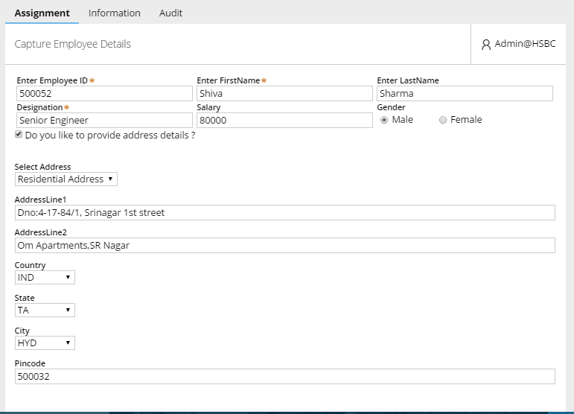

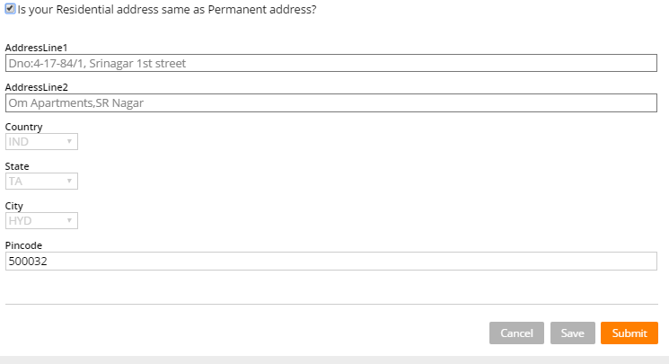

**Develop the above scenario using auto complete**

**3)** **Develop A PRPC Scenario Using Following Steps with Data transforms**

Step1: Create Dynamic Layout with 3 radio buttons as 1Week 2Weeks and 3Weeks

Step2: Create Grid Repeat Layout with 2 date time pickers

**Conditions:** whenever user selects 1week in Grid Layout 1 row with 2 date time pickers should come, if he selects 2weeks 2 rows with 2 date time pickers in each row should come and if he selects 3weeks 3 rows each with 2 date time pickers should come

**Output:**

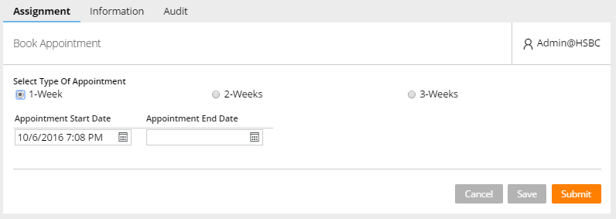

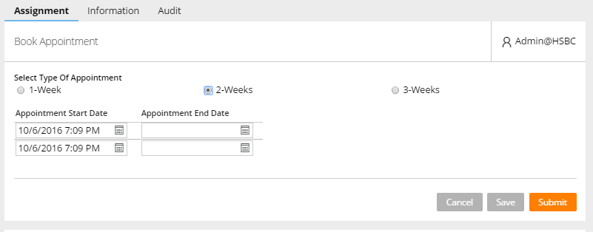

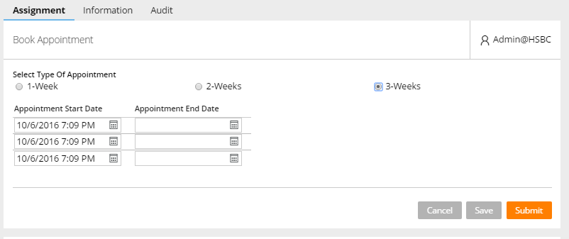

**4) Develop A PRPC Scenario Using Following with AutoComplete**

Step1: Create 2 autocomplete as Product and Category

**Conditions:** whenever user selects Category the related products should be populated into product autocomplete.

**Output:**

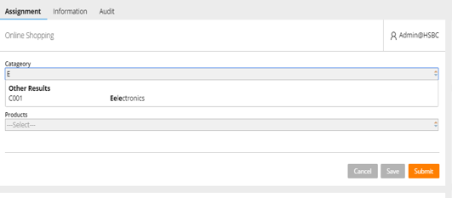

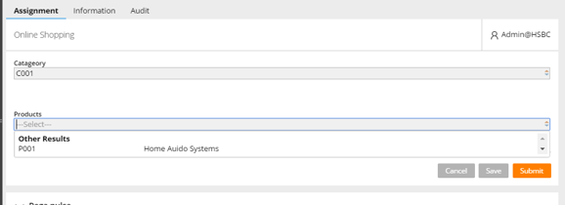

**5) Develop a PRPC scenario using following**

Step1: Create a Dynamic Layout with a button as Get All Employee Details

Step2: Create a Grid Layout for populating Employee Details whenever the above button is clicked

Step3: Create a Dynamic Layout with another button as Copy Selected Employee Details

Step4: Create another Grid Layout for Populating Employee Details when the above button is clicked

**Conditions:** whenever a user clicks on Get All Employee Details button all the available employee records should be populate into Grid with a check box, when the user checks the respective records and clicks on Copy Selected Employee Details button respective records should be populated into grid.

**Output:**

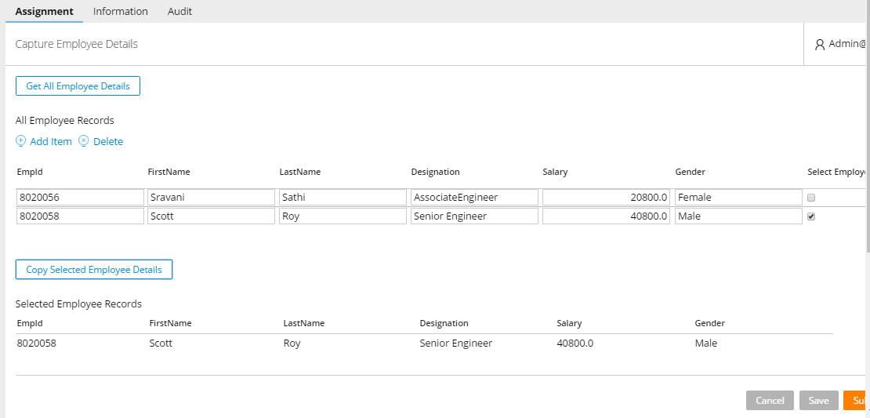

**6) Develop a PRPC scenario using following**

Step1: Create a Dynamic Layout with two text fields

Step2: Create a Dynamic Layout with three buttons

Step3: Create a Dynamic Layout with a text field

**Conditions:** Whenever a user enters a value in tow text fields and clicks on any one of the buttons respective mathematical operation should be performed and the result should be displayed in result text field

**Output:**

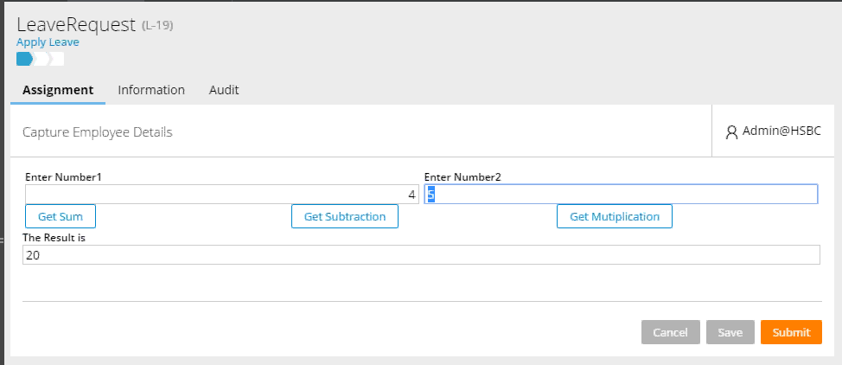

7) **Develop A PRPC Scenario Using Following**

Step1:

INPUT:

OUTPUT:

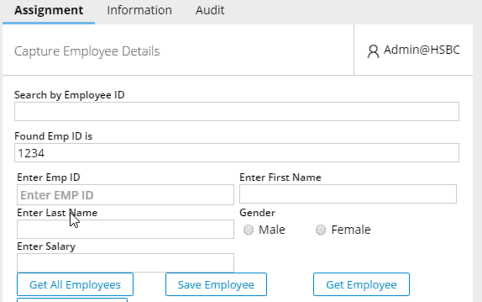

8) **Develop a PRPC scenario using following with Decision Tables**

Step1: Create three text input fields for marks

Step2: Create a button as get average

Step3: Create a text input field for average

Step4: Create a button for getting grade

Step5: Create a text input field for displaying grade

**Conditions:** Whenever user enters marks in the text fields and clicks on get average button average has to be calculated and displayed in average text box for get average button make use of data transforms, if average is not null then we have to display grade button for this button we should make use of activity, if user clicks on grade button respective grade should be displayed based on decision table.

**Output:**

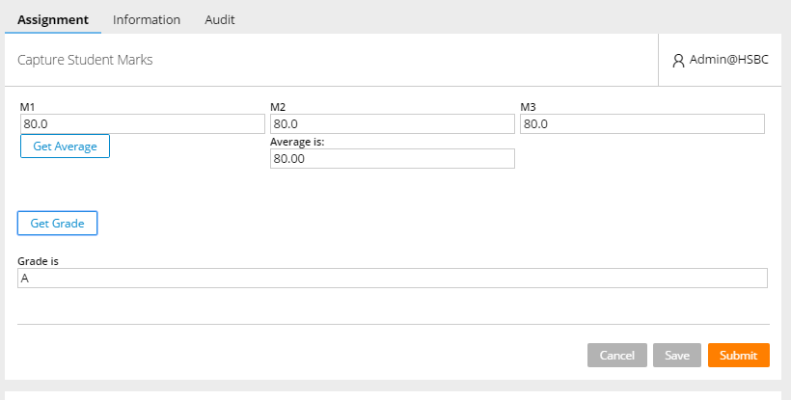

9) **Develop a PRPC scenario using following with Decision Tables**

Step1: Create a text input field for credit card score

Step2: Create a button

Step3: Create a text input field for credit card type

**Conditions:** whenever user enters credit card score and clicks on button respective credit card type should be displayed based on decision table.

**Output**:

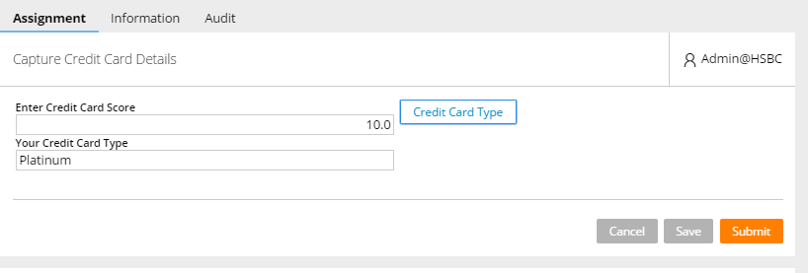

10) Data pages

11) Simple and compound interest